|  |
| --- |
| [http://medical.ebaotech.com/life/images/logo_ebaotech.gif](http://www.ebaotech.com/) |
| <Confidential> |
| eBaoTech PeakRe System  Business Specification Document |
|  |
| eBaoTech Corporation  **Client Name: PeakRe**  **Feature: IBNR Uploading**  **Version: V 3.0**  **Status: Draft** |
|  |

Confidentiality Notice

© Copyright 2015 eBaoTech Corporation

All rights reserved. Reproduction in whole or in parts is prohibited without the prior written consent of the copyright owner.

The information contained in this document is strictly confidential and must not be disclosed to any other person by the client or by any of its employees without the prior written consent of copyright owner.

Client is permitted to disclose the information only to those of its employees and/or professional advisors who need to have access to it and client will notify such employees and/or professional advisors of the terms of this notice.

For any questions or remarks on this document, please contact eBaoTech Corporation +86 (21) -61407777.

Document History

Change Record

| Date | Author | Version | Details | Reviewer |
| --- | --- | --- | --- | --- |
|  |  |  |  |  |
| 26/10/2015 | Sophie Duanmu | V 1.0 | Initial version | Sarah Zhu |
| 03/11/2015 | Sophie Duanmu | V 2.0 | Update |  |
| 11/11/2015 | Sophie Duanmu | V 3.0 | Update |  |

Related Documents

| Release Date | Doc Resource | Document Name | Version |
| --- | --- | --- | --- |
|  |  |  |  |

Contents

1 General Overview 5

2 Business Requirement 5

2.1 Segment setup 5

2.2 IBNR uploading 5

3 System Solution 6

3.1 Segment query and create 6

3.2 IBNR uploading 7

3.3 Posting of data 8

# General Overview

# Business Requirement

The IBNR is handled at segment level – a bundle of programs. System should provide the ability to set up the segment and define the condition of each segment. Technical accounting users need to upload segment IBNR in system for each financial quarter and system should book the delta value of account automatically. IBNR is handled in this way:

Initial data is inputted by data conversion when implementation of new system. For each financial quarter, system generates an entry item of IBNR opening as the IBNR value of previous financial quarter and the sign is opposite. During IBNR uploading, user upload new total updated IBNR data as IBNR closing.

Data to be posted to GL is calculated as:

|  |  |
| --- | --- |
| **Sign** | **Entry item** |
| + | IBNR Opening |
| - | IBNR Closing |
| =IBNR to be posted | |

## Segment setup

System should provide the ability to maintain IBNR segments in system. Initial data could be set up according to existing segments in PeakRe. System shall also be able to enable users (usually analytical team) manually create and maintain segment as a group of programs.

There are should be three dimensions to define a segment:

* CoB (Class of business): refer to the main class of business on program condition.
* UW area (Cedant country)
* Program nature: either proportional or non-proportional.
* Segment could not be deleted or edited in system but could set as invalid status.
* User should be able to query existing segments.
* Segment IBNR under underwriting view (cedant quarter view) and financial view should be both included in segment detail.

## IBNR uploading

At PeakRe, IBNR records are prepared by analytical team and accounting team will work out the amount to be booked, so that finally the UY IBNR tallies with analytics. System shall provide the ability of uploading IBNR booking of each segment instead user manually input.

* The uploading excel files should follow a certain template.
* General validations should be applied such as data format validation.
* Other business or accounting accuracy validations, such as: there should not be any duplicate IBNR records.
* For segment with IBNR data but not be included in IBNR uploading excel file of this financial quarter, system should automatically generate entry item of IBNR closing in system for calculation.
* System should finally automatically post IBNR data to GL after uploading is successful.

# System Solution

## Segment query and create

One individual menu called segment management would be available for users to manage or create segments. User with menu authority could be able to access the function.

* Query existing segment

The user interface for segment query is proposed as below:

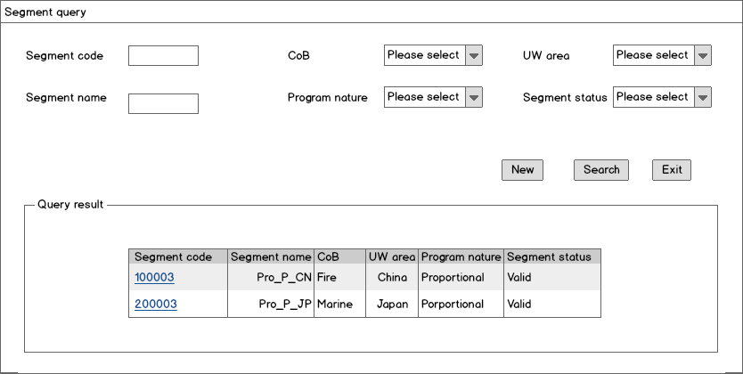

* + Segment code is a unique number that system generates for each segment.
  + There is no duplicate validation for invalid segment. System will not block the process if the segment name or three segment conditions are the same with existing invalid segment. On the other hand, if the name or three conditions of new segment is the same with existing valid segment, system will block the creation process.
  + To click the hyperlink of segment code, system will turn to segment detail page.
* Segment details

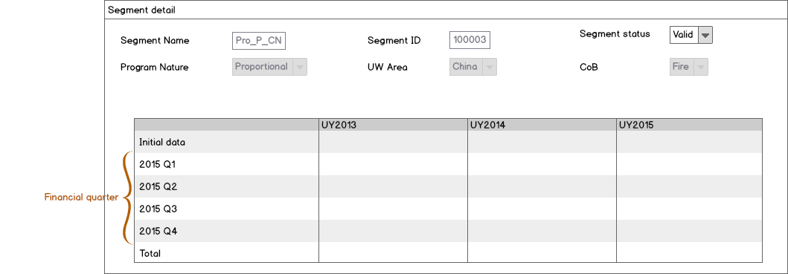

* + Segment could not be deleted in system but could only be set to invalid status.
  + Other conditions are not allowed to change.
  + Uploading records and total amount of IBNR is displayed in the IBNR summary table. If there is no uploading, the summary table will show as blank.
* Create segment

By clicking the button **Create** on segment query page, user could input related information or condition to create a new IBNR segment.

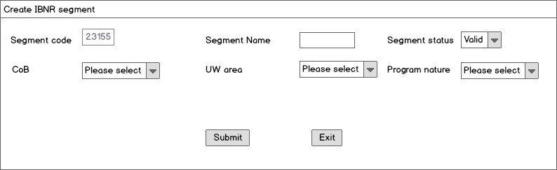

* Segment status is default as valid. System will promote a warning message if the segment is created with invalid status.
* As long as segment status is valid, it is allowed to upload and post IBNR under the segment.

## IBNR uploading

System will provide excel uploading function to input IBNR data.

* Template:

|  |  |  |  |  |  |
| --- | --- | --- | --- | --- | --- |
| **Segment Name** | **UW area** | **CoB** | **Program type** | **UY2013(Amt)** | **UY2014(Amt)** |
|  |  |  |  |  |  |

* General validations
  + Underwriting year should be between 2013 and current year.
  + Data format
  + Excel Format validation
  + No duplicated data in one excel file.
  + Validation if each line of record could be mapping with an existing segment.

System would promote message to inform user what is invalidated if validations do not pass.

* The IBNR amount in excel is the new total value and system is able to automatically calculate the delta amount to be posted instead of user manually input.

## Posting of data

After successfully uploading of IBNR data, system would automatically calculate and post the delta value of IBNR to GL. The posting is under current financial quarter.